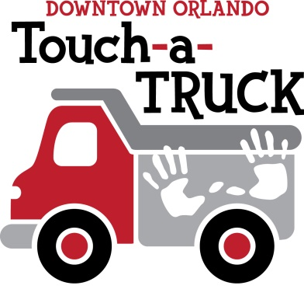
EVENT DATE: February 10, 2024 TIME: 9am-1pm
LOCATION: Trinity Downtown 123 E Livingston St. Orlando
CONTACT AND VEHICLE INFORMATION
PLEASE REMIT BY JANUARY 10, 2024:
EMAIL TO: Terry Boggs, mammierocks@yahoo.com
(Please return this page when remitting participant contact vehicle information. If providing more than one vehicle, remit additional copies of the Vehicle Information section per vehicle.)
CONTACT INFORMATION: (One per Company / Organization)
Name: Click or tap here to enter text. Title: Click or tap here to enter text.
Business Address: Click or tap here to enter text.
Office Phone: Click or tap here to enter text. *On-Site Cell (For Emergencies): Click or tap here to enter text.
Email: Click or tap here to enter text. Company Website: Click or tap here to enter text.
Can you provide a certificate of liability insurance upon request? YES NO (It is suggested that a copy of the Certificate of Liability be remitted along with this form.)
EVENT PASSES: Number of event passes (max. 10): Choose an item. (Will be mailed to business contact name and address prior to event. You can contact Truck Chair, Terry Boggs, by email at mammierocks@yahoo.com or call 407-797-7345 for alternate arrangements.)
VEHICLE INFORMATION: (Please use a different form for each vehicle)
Business Name / Owner of Vehicle: Click or tap here to enter text.
Description of Vehicle (includes any special instructions, especially larger vehicle(s), i.e. turns, etc.):
Click or tap here to enter text.

Length: Click or tap here to enter text. Width: Click or tap here to enter text. Height: Click or tap here to enter text.
Requires Pavement? YES NO Make: _________ Model: _________ Year: ______
Approx. Weight of Vehicle: ______________ Value of Donation / Operator(s) Time: $_______________
Category of Vehicle / Company (check all that apply): Construction & Engineering Public Utilities
Not-for-Profit Government Military Emergency Vehicles Other: Click or tap here to enter text.
For Emergency Vehicles Only: Is this particular unit on-call during the event? YES NO
Will contact person above be present at event on Saturday, FEB 10, 2024? YES NO (If no, please provide contact information for driver/operator (and any other operators) required for the oversight and safety of your vehicle):
Driver / Operator: Click or tap here to enter text. On-Site Cell Phone: Click or tap here to enter text.
On Site Asst. Operator #1 (if required) Click or tap here to enter text. Cell Phone: Click or tap here to enter text.
(***NOTE*** If driver/operator for day of event is not yet known, please still remit this form by January 10, 2024. Truck Chair will gladly follow up with those companies requiring additional time for coordination of efforts prior to event.)

MEDIA: Would your company permit our use of your company logo(s) or vehicle photo(s) for promotional purposes? If yes, please email your logo(s) and vehicle photo(s) to Terry Boggs at: mammierocks@yahoo.com
Would you like a link to your website? If yes, please list website address: Click or tap here to enter text.
Authorized Signature for Media: Click or tap here to enter text. Date: Click or tap here to enter text.
VENDOR / SPONSORSHIP: (Please complete only those that apply)
Vendor (with truck participant): YES NO REQUEST MORE INFO. / RECOMMEND VENDOR
If yes, please provide: (1) Approximate dimensions of your company’s vendor area: Click or tap here to enter text.
(2) Will vendor area require location by vehicle? YES NO (TLC will try to accommodate request)
ADDITIONAL SPONSORSHIP LEVELS: YES (see attached form) NO
TRUCK / VENDOR CHAIR CONTACT INFO.: (please contact for additional information or any other arrangements)
Touch-a-Truck Co-Chair (Terry Boggs) Email: mammierocks@yahoo.com Phone (407) 797-7345
Touch-a-Truck Co-Chair (Ken Boggs) Email: umpboggs@yahoo.com Phone (407) 797-7346

